Assignment 1 Airfoil analysis and preliminary design
  - Academic year: 2025-2026

Name | Dennis Heintz
Student ID | 6219675
Email address | dheintz@tudelft.nl

Date : 27.01.2026

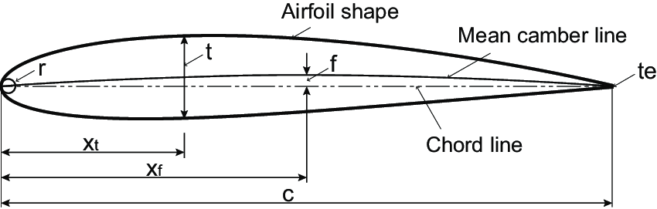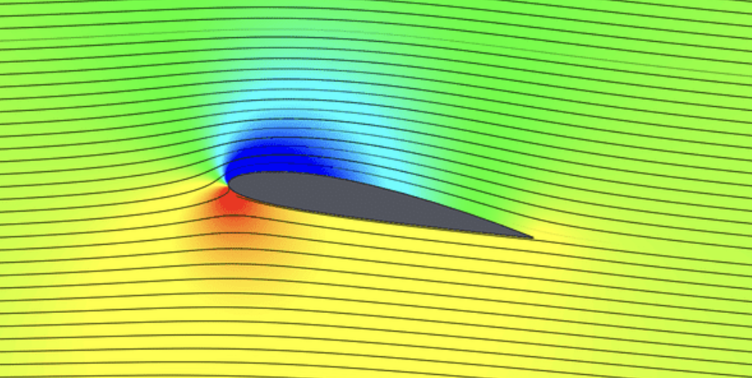

Contents

1 Introduction 3
2 Part 1 Airfoil analysis 3
2.1 The Prandtl boundary layer equations 3
2.2 XFOIL download and installation 6
2.3 Personal airfoil 6
2.4 Lift and drag polars 8
2.5 Transition point 9
2.5.1 Free transition 9
2.5.2 Fixed transition 9
3 Airfoil improved design 12
3.1 Airfoil design 12
3.2 Shape optmization 13
3.3 The laminar separation bubble 14
3.4 Forced transition 17
3.5 Critical roughness height 18

Introduction
The aerodynamic characteristics and performance of any aircraft part exposed to the external flow is significantly influenced by the state of the boundary layer (BL), that can either be laminar or turbulent. To determine in how far the BL transition on a 2D airfoil is affected by its shape and the atmospheric turbulence scale, this assignment addresses the airfoil design in relation to the transition point location. The so-called $e^{n}$-method is a very good method for the estimation of BL-transition as it is fast and rather accurate. Many airfoil design and analysis programs employ this $e^{n}$-method. In this assignment you will use the program XFOIL to determine the effect of shape changes and the user selected amplification factor $n$ on performance of a 2-dimensional airfoil.

Part 1 Airfoil analysis

The Prandtl boundary layer equations
Write down the Prandtl Boundary Layer Equations (preferably pen on paper) and add a scan in the frame provided below. In the 2nd frame, write down an explanation of what is meant by the various terms.

Handwritten BL equations and explanation of terms
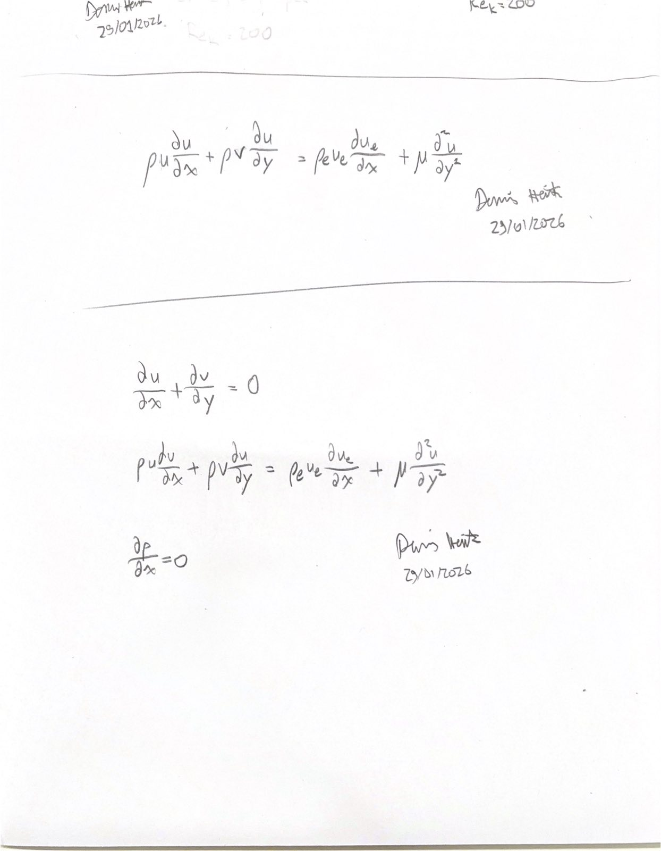

Additional description of the BL equations
The equations above represent Prandtl’s Boundary layer equations in 2D. Of note is that the Prandtl Boundary Layer equations are only valid for flows with high Reynolds numbers where the viscous forces only dominate in a small region near a wall and the rest of the flow field can be modelled as inviscid. For such flows one can assume that the pressure gradient in the y direction is 0.
For the x momentum equation, the left side represents the momentum in the flow in the x direction. The first term on the right side represents the pressure gradient in the x direction of the flow, which in this case is determined by the pressure gradient in the inviscid region of the flow. Therefore, the Euler equation can be applied for the pressure gradient. Lastly, the final term represents laminar shear stress.
Do the same for the so-called first compatibility equation and the form of the velocity
distributions in the boundary layer. Clearly indicate the influence of the streamwise pressure gradient.

Handwritten First Compatibility equation and velocity distributions in the BL
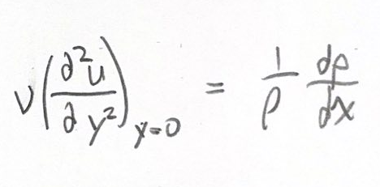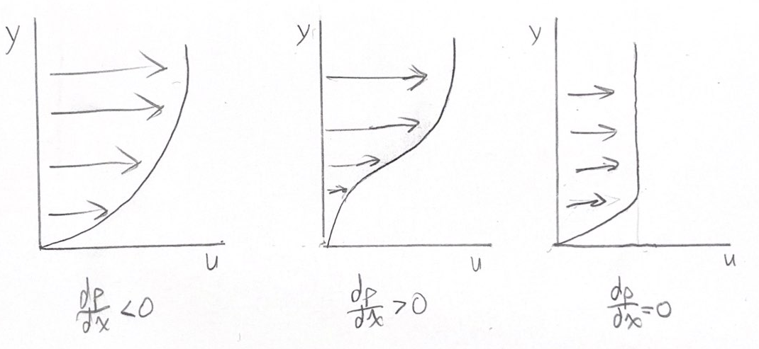

Additional description of the 1st compatibility equation
As can be seen by the first compatibility equation, where u=0 and v=0 at the wall, the pressure gradient in the x direction influences the curvature of the velocity profile. This also shows that a negative pressure gradient is favorable to keep a flow laminar as it keeps the most momentum near the wall. Whereas a positive pressure gradient moves momentum away from the wall as can be seen by the concave shape. Finally, a constant pressure gradient creates a linear profile. This behavior can explain the boundary layer behavior over an airfoil where the flow experiences both negative and positive pressure gradients.

XFOIL download and installation
If you did not already do so, download the XFOIL software and the manual from the internet (for example from: https://web.mit.edu/drela/Public/web/xfoil/ ) and install it in a local directory. Make yourself familiar with the theoretical background of this solver.

Personal airfoil
Determine your personal 4-series airfoil shape that you are going to investigate in this assignment. The procedure for this can be found in Appendix A.
Please note that failure to work with the right airfoil shape will result in zero credits for Assignment #2.

Show the calculation and its results and clearly state what airfoil shape you use (provide a figure with the airfoil shape as well)

Description of personal airfoil determination
Last 3 digits of my student number: 675
N = 6 + 7 + 5 = 18
Second digit of my student number: 2
NACA airfoil: 2218

Figure of the selected airfoil
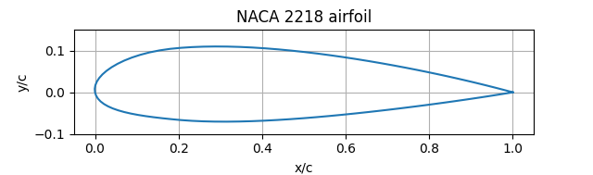

Lift and drag polars
For your personal airfoil, calculate the lift and drag polar between -2 and 8 deg angle of attack using the default value of the amplification factor ($n=9$) and produce clear plots of the results (no screen prints). Use a chord-based Reynolds number of $Re=0.8×{10}^{6}$ and leave the Mach number at $M=0$ (this indicates that no compressibility correction is applied).
Note:
In case your personal airfoil has a rather steep camber change close to the leading edge or the trailing edge this may lead to issues with the viscous calculation. If this is the case (please show your original airfoil and the issue) then use the reference airfoil NACA2510.
Lift and Drag polars
Airfoil name: NACA 2218
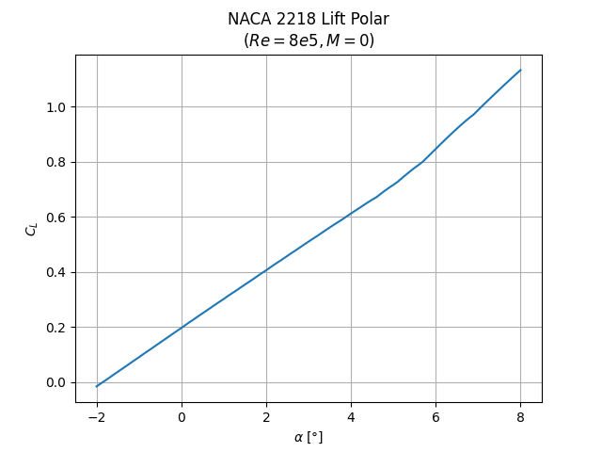
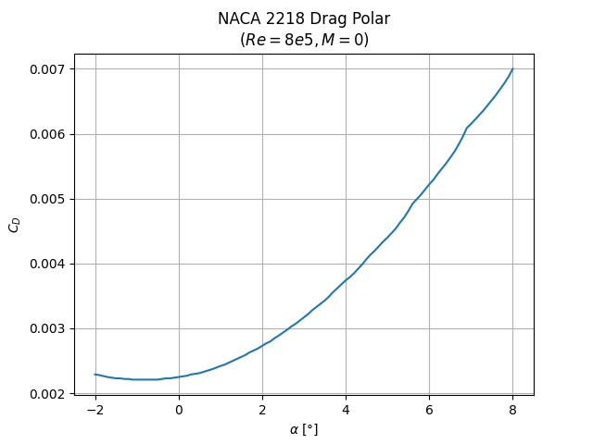
Underneath, shortly discuss whether these polars agree with your expectation.
Discussion on Lift and Drag polars
The two polars above match the expected results very well.
As expected, the lift coefficient increases linearly as the airfoil does not stall within the chosen range of angle of attacks. A slight change in the lift coefficient slope does occur around an angle of attack of $5°$, which can be explained by the presence of a laminar separation bubble that can increase the coefficient of lift of an airfoil.
The drag polar also meets expectations as it shows a quadratic relationship between the angle of attack and coefficient of drag of the airfoil. At higher angles of attack, however, the parabola does not appear smooth, which, again, could be explained by the presence of a laminar separation bubble or by limitations of the solver to accurately model drag coefficients.

Transition point

Free transition
Check the change in the chordwise location of the transition point with increasing angle of attack and produce a clear plot showing the effect. Underneath the plot, shortly discuss the trend of this line.
Plot of the transition point location versus angle of attack
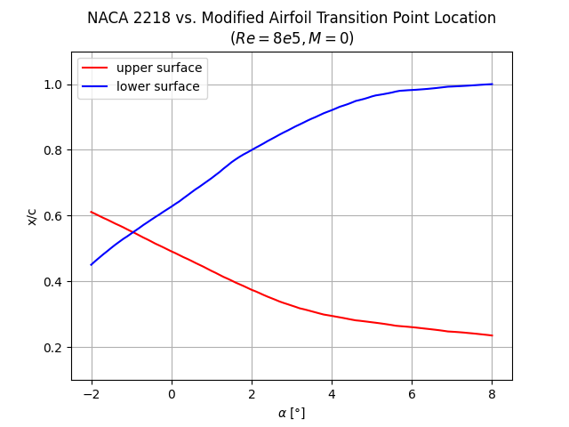
The plot on the left shows that the transition point moves forwards on the upper surface and backwards on the lower surface as the angle of attack increases.
This follows from the changes in pressure gradients that are caused by the change in angle of attack. As the angle of attack increases, the suction peak on the upper surface increases and results in steeper pressure gradients which cause the boundary layer to transition sooner.
The opposite is true for the lower surface where the pressure gradients become more favorable for the laminar boundary layer to continue farther along the airfoil before transitioning, if at all.

Fixed transition
Based on your own calculations, shortly discuss what happens to the drag coefficient as you force the transition to be in a specific location. In practice of wind-tunnel testing, this is done by adding roughness to the surface. See the discussion in the lecture series on “artificial transition” (3D, 2D and ZZ-roughness). Depending on the airfoil shape the removal of the laminar separation bubble through careful forced transition leads to a lower drag coefficient (see later)
In XFOIL, the transition point location can be changed through selecting the menu:
vpar xtr. Add a plot of the drag coefficient versus the point of forced transition (on the upper side only) for a fixed value of the lift coefficient, $C_{l}=0.4$.
Plot of the drag coefficient versus the transition point location at $C_{l}=0.4$.
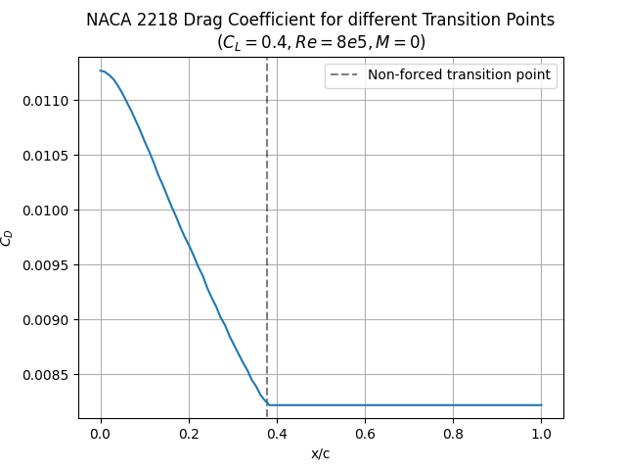
In the frame underneath, explain how and why the drag coefficient changes with the transition point location.
Discussion on the effect of forced transition on the drag coefficient.
As can be seen in the plot above, a lower drag coefficient cannot be achieved by tripping the boundary layer farther upstream, and setting the boundary layer to trip past its natural tripping point has no effect as the boundary layer is already turbulent.
The change in drag coefficient is a combination of a change in the pressure drag and skin friction drag. Due to the shape of the velocity profile of a turbulent boundary layer, the velocity gradient near the airfoil surface is greater than that of a laminar boundary layer. This results in a greater skin friction drag which is proportional to the velocity gradient at the wall. The pressure drag, on the other hand, decreases when the transition is forced upstream, as a turbulent boundary layer enhances the mixing inside the boundary layer and decreases the boundary layer thickness which helps in preventing flow separation. This prevents the laminar separation bubble from forming, which is a large source of pressure drag at low Reynolds numbers.
In the case of this airfoil, the contribution of the friction drag is larger than that of the pressure drag, because of the low Reynolds number, which leads to an overall increase in drag when the boundary layer is tripped upstream of its natural transition point.
Now return to the free transition case and produce a plot that shows the frictional coefficient, $C_{f}$, along the upper side of the airfoil for $α=0$ and $α=4$. Annotate this plot and indicate what type of flow (laminar, transitional, turbulent) is found in the various areas.
Plot of $C_{f}$ along the chord for the 2 angles of attack. Annotate!
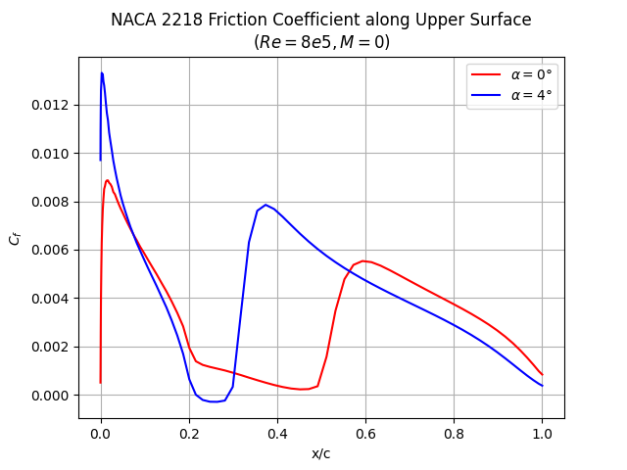
D
C
B
A
A – Laminar Boundary layer
B – Transitional region
C – Turbulent Boundary layer
D – Flow Reversal
Shortly discuss your observations in the frame underneath.
Descriptive text in which this $C_{f}$ plot is discussed.
The plot above shows the variation of the friction coefficient across the upper surface of the airfoil. As highlighted, 3 main regions of interest exist: region A highlights the part of the airfoil where the boundary layer is laminar, in region B, the boundary layer is transitional, and finally in region C, the boundary layer is turbulent.
Even though the friction force is lower in a laminar boundary layer relative to a similar turbulent boundary layer, as discussed earlier, the coefficient of friction of the laminar boundary layer is higher in this plot as the coefficient of skin friction is proportional to the velocity gradient at the wall which is highest at the suction peak of the airfoil.
Region B represents the transitional boundary layer and highlights the biggest difference between the two angles of attack. At $0°$, the boundary layer trips and transitions from laminar to turbulent as expected, however at an angle of attack of 4$°$, the coefficient of friction becomes negative in this region (See D on the graph) before becoming turbulent. This indicates that flow reversal occurred at this point and that the boundary layer separated from the airfoil. This is clear evidence of the presence of a laminar separation bubble on the airfoil. In addition, the presence of the laminar separation bubble greatly affected how fast the boundary layer transitioned to turbulent, which leads to a larger part of the airfoil experiencing the turbulent boundary layer. Finally, the higher friction coefficient after the laminar separation bubble corresponds to the higher pressure gradients that are found past a laminar separation bubble on a pressure coefficient curve.
Region C represents the turbulent boundary layer. As expected, the slope in this region is shallower than that of the laminar boundary layer. This follows from mixing that occurs inside a turbulent boundary layer which brings new momentum near the wall and causes a slower change in the velocity gradient at the wall and, hence, a slower decrease in shear stress.

Airfoil improved design
The airfoil that you have been using in Part 1 may not be optimum w.r.t. its performance (glide ratio $C_{l}/C_{d}$) at cruise lift coefficients. Therefore, in this part of the assignment you will be using the inverse airfoil design option in XFOIL to manually design an airfoil that has an increased amount of laminar flow at the wing upper side, thus improving the lift/drag ratio.

Airfoil design
Calculate the lift to drag ratio $(C_{l}/C_{d}$) of the airfoil used in Part 1 at a fixed cruise lift coefficient of $C_{l}=0.4$. This can be done by selecting CL in the OPER menu. Enter the ratio (sometimes referred to as the ‘glide ratio’ of the original airfoil.
$C_{l}/C_{d}$ ratio of original airfoil
48.67
Explain how the airfoil shape may be adapted to improve the lift to drag ratio of this airfoil.
Rationale of airfoil design for improved performance at cruise condition
For a given lift coefficient, the lift-to-drag ratio can only be improved by lowering the drag coefficient. As discussed in previous parts, the largest contributor to the drag coefficient is the friction drag and that a laminar boundary layer has a has a relatively lower friction drag to a turbulent boundary layer. Therefore, the goal should be to keep the boundary layer laminar for as long as possible across the airfoil.
This can be achieved by reducing the adverse pressure gradient across the airfoil to prevent the degradation of the laminar boundary layer. This can be achieved by flattening the upper surface of the airfoil which will delay transition until farther downstream.
Underneath, add hand drawings explaining the proposed change in the airfoil shape.
Hand drawings explaining the intended design change
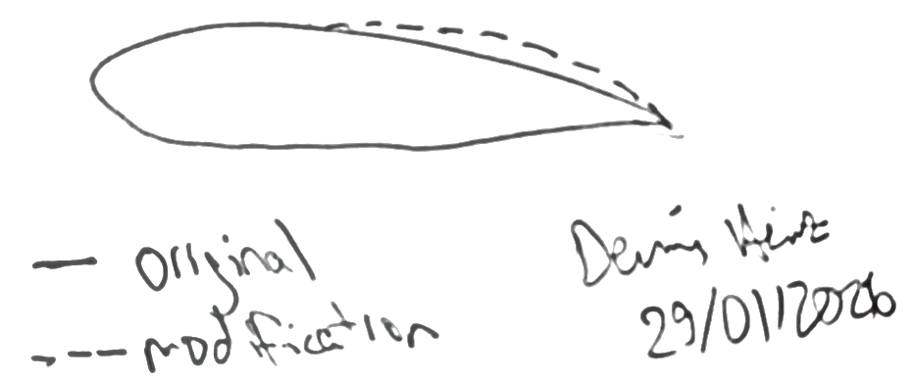

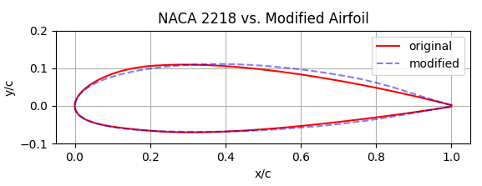

Shape optmization
Use the inverse airfoil design routines in XFOIL to manually design an airfoil with an increased amount of laminar flow at $C_{l}=0.4$ and present its higher $C_{l}/C_{d}$value.
Make sure that the original airfoil and the optimized airfoil have the same relative thickness, $t/c$! You can do this by scaling the airfoil thickness using a specific routine in XFOIL gdes scal 0 (to allow only y-scaling) 1 (maintains the x-scaling) <value> (this will be the scaling factor for the y-coordinate).
Plot and shortly discuss the typical differences in the pressure distribution between the original and the modified one.
Plots of the pressure distribution for original and improved airfoil. Annotate key features.
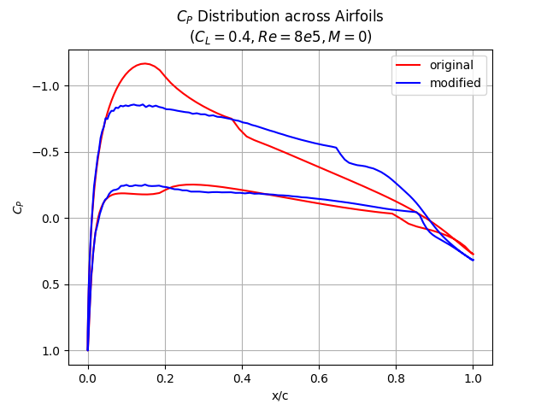
As planned, the adverse pressure gradient was reduced on the upper surface in the plot above. The increase in thickness lead to a smaller suction peak and then a more gradual increase in pressure coefficient until the end of the airfoil. This delayed the transition of the boundary layer from roughly x/c=0.37 to x/c=0.64. The bottom surface was also modified slightly to decrease the adverse pressure gradient.

Show and discuss the effect that the airfoil shape adaptation has on the position of the transition point.
Plot: Effect of the shape optimization on transition point location.
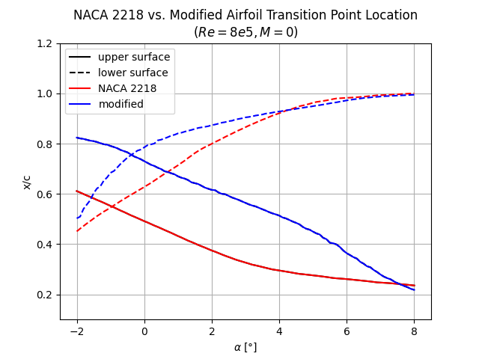
As can be seen in the plot, the transition point is consistently delayed to farther downstream for the modified airfoil when compared to the original NACA 2218 airfoil. As intended, the delay in transition is especially noticeable on the upper surface of the airfoil where the adverse pressure gradients are greatest. This, again, shows that the modifications made were successful in reducing the drag of the airfoil as the transition was delayed.
Summarize the effect airfoil optimization in the table underneath.
Fixed lift coefficient:
Airfoil | $$C_{l}/C_{d}$$
Original: | 48.67
Adapted: | 58.15

The laminar separation bubble
At low Reynolds numbers the airfoil may develop a so-called laminar separation bubble. This has consequences for the drag and the stall behaviour of the airfoil. To analyze the effect of a bubble on airfoil performance perform the following tasks.
Shortly explain why the laminar separation bubble may lead to an increase in the drag coefficient. Use a hand drawing to show the flow pattern (streamlines) in and around the bubble and indicate (in a qualitative way) how both the pressure drag and skin friction drag change in the bubble region compared to a case where no bubble is present. Remember to add a date and signature to the drawing.
Hand drawing of the laminar separation bubble and explain through written annotations.
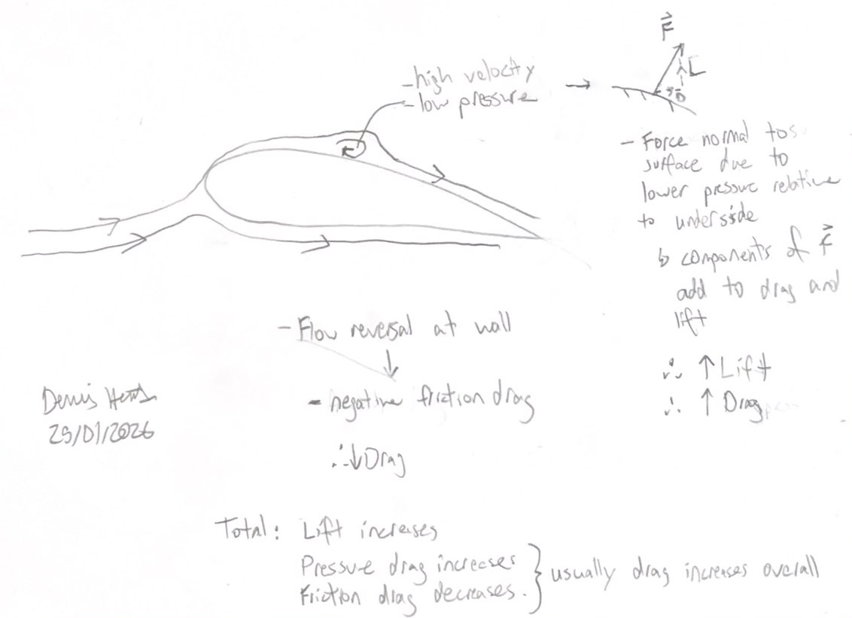

Take the original airfoil of Part 1 and select a low Reynolds number (typically between $2×{10}^{5}$ and $5×{10}^{5}$) at which this airfoil produces a clearly recognizable laminar separation bubble. For the n-factor now use $n=12$.
Plot of the pressure distribution showing the laminar separation bubble. For comparison add the potential flow $C_{p}$ distribution. Annotate the plot to indicate clearly where the bubble if present.
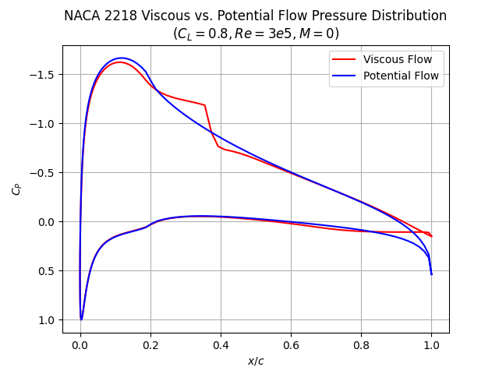
Bubble!
The laminar separation bubble is clearly visible in the plot above. The region shows a more negative pressure coefficient compared to the potential flow case, where no bubble is present. As this increases the area in the plot between the upper and lower surface, the bubble results in the expected increase in lift.
The length of the bubble will become larger when the Reynolds number is lowered. Explain shortly why this happens. Which point will be modified strongly by the increased Reynolds number, the start (separation point) or the end (transition location)?
Explanation of the effect of Reynolds number on bubble length
The mechanism that reattaches a laminar separation bubble is the transition of the boundary layer to turbulent. This reintroduces momentum into the boundary layer and leads to reattachment. At low Reynolds numbers, the transition takes longer and, as a result, leads to a longer bubble. At higher Reynolds number the flow more quickly transitions and therefore reattaches sooner resulting in a shorter bubble. Therefore, the reattachment point is influenced more by the Reynolds number as it dictates how quickly the bubble reattaches. The separation point on the other hand is more dependent on the pressure gradient.

Forced transition
Using the same airfoil, remove the laminar separation bubble to reduce the drag coefficient at a fixed lift coefficient (you may choose one). For this, carefully select a position to fix transition on the upper side of the airfoil. Present the drag coefficients found in a table.
Plot of drag coefficient versus forced location of transition
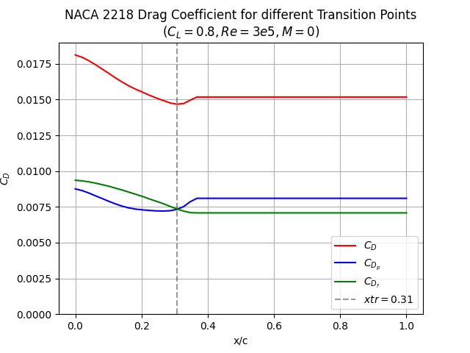
What is the distance between the point of natural transition and the fixed position that you selected? Discuss why a smaller or larger distance will not work to lower the drag.
Discussion on the selected forced transition location
Forcing the transition at a location of x/c=0.31 results in the lowest possible drag coefficient for the chosen lift coefficient. This point is the sweet spot where the friction drag is low enough and the pressure drag is about to increase due to the formation of a laminar bubble.
Moving the transition point upstream would result in a higher overall drag as the friction coefficient would increase due to the shorter laminar boundary layer and longer turbulent boundary layer.
Moving the transition point farther downstream would also result in a higher overall drag as a laminar separation bubble would form if transition was delayed any more. As discussed, laminar separation bubbles increase pressure drag as a component of the normal force created by the low pressure area is facing downstream.

Critical roughness height
Explain what is meant with the so-called “critical roughness height”. Add a hand drawing to clarify.
Hand drawing to support the discussion on critical roughness height
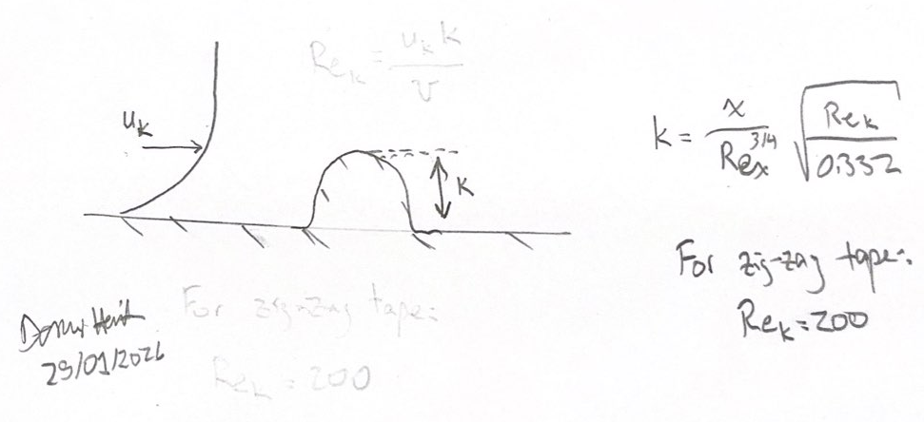

Discussion on critical roughness height
The critical roughness height is the minimum height of a disturbance on a wall that forces transition in a boundary layer from laminar to turbulent. A height lower than the critical roughness height would have a negligible effect on the boundary layer flow and a height higher than the critical roughness height would result in transition from laminar to turbulent. The critical roughness height can be important as it provides the minimum value for the surface disturbance, which is favorable as the larger the disturbance, the greater the drag penalty.
There are different methods of adding roughness to a surface, such as 3-D roughness, 2-D roughness, and zig-zag roughness. Each has an associated ${Re}_{k}$ value that then allows for one to solve for the critical roughness height based on the chord and its associated Reynolds number.
Discuss a case in which you would apply roughness on an aircraft to increase its performance. What aircraft is it and what hat type of roughness would you apply? Where would you position it?
Discussion on application of roughness.
Gliders are a good example of an application of additional surface roughness to increase performance. As gliders operate at low Reynolds numbers and can encounter high angles of attack while soaring in a thermal updraft, added surface roughness is required to ensure attached and predictable flow over the wings. Flow separation could occur if the boundary layer was not addressed at the leading edge which could quickly lead to the wing stalling. The added roughness would transition the laminar boundary to turbulent at the leading edge and improve the flow over the wing. Efficiency is also an important factor for gliders which requires the surface roughness to add as little drag as possible while still ensuring transition. Therefore, using zig-zag tape would be best as it has the lowest critical height which minimizes drag.

Appendix A. Airfoil selection
The form (NACA designation) that you analyze is based on your student number. To find the airfoil shape that you need to investigate within this assignment do the following:
- Take the last 3 digits of your student number, for example: 989, and take the sum, which we will denote 𝑁. In this example: 𝑁=9+8+9=26. This number determines the relative thickness of the airfoil you are going to investigate.
  - In case your number is 5 or lower, use $N$=10
  - In case your number is between 5 and 10, add a zero in front (so 9 becomes 09).
- The first digit of the NACA designation is always 2
- The second digit of the NACA designation is the second digit of your student number.
Some examples of this calculation are provided in the table underneath (check).
Student number | N | NACA Airfoil
4223977 | 23 | 2223
4218124 | 7 | 2207
4303784 | 19 | 2319
4712900 | 09 | 2709
4599667 | 19 | 2519
4391594 | 18 | 2318
4724143 | 8 | 2708
4221000 | 10 | 2210
4078005 | 10 | 2010
Please note that failure to work with the right airfoil shape will result in zero credits for this Assignment.

